# **Spatial Realignment of German Voters and Germany's Regional Cleavage: Case of the Green Party in the 2019 European Elections**

**Ilia Viatkin**

## **Appendices**

***1. 2014 and 2019 European elections results of the Green party***

**Table 1.1. Comparison of the 2014 and 2019 European elections results of the Green party with respect to federal state, Eastern Germany[1]**

|  |  |  |  |
| --- | --- | --- | --- |
| *Federal state* | *The Greens’ European elections results* | | *Difference (%)* |
| 2014 | 2019 |
| Brandenburg | 57,057 (6.1%) | 147,224 (12.3%) | +6.2 |
| Mecklenburg-Vorpommern | 30,780 (5.1%) | 81,285 (10.8%) | +5.7 |
| Saxony | 97,256 (6.0%) | 212,407 (10.3%) | +4.3 |
| Saxony-Anhalt | 38,485 (4.8%) | 89,345 (9.2%) | +4.3 |
| Thuringia | 45,432 (5.0%) | 90,409 (8.6%) | +3.6 |
| **Average percentage:** | **5.4%** | **10.24%** | **+4.84** |

Source: Federal Returning Officer Federal Statistical Office (2019).

**Table 1.2. Comparison of the 2014 and 2019 European elections results of the Green party with respect to federal state, Western Germany**

|  |  |  |  |
| --- | --- | --- | --- |
| *Federal state* | *The Greens’ European elections results* | | **Difference (%)** |
| 2014 | 2019 |
| Baden-Württemberg | 517,842 (13.2%) | 1,135,696 (23.3%) | +10.1 |
| Bavaria | 466,916 (12.1%) | 1,102,420 (19.1%) | +7 |
| Bremen | 33,997 (17.6%) | 66,390 (22.7%) | +5.1 |
| Hamburg | 95,169 (17.2%) | 247,719 (31.1%) | +13.9 |
| Hesse | 238,657 (12.9%) | 598,460 (23.4%) | +10.5 |
| Lower Saxony | 324,221 (10.9%) | 846,522 (22.6%) | +11.7 |
| North Rhine - Westphalia | 688,410 (10.1%) | 1,854,487 (23.2%) | +13.1 |
| Rhineland - Palatinate | 139,047 (8.1%) | 327,704 (16.7%) | +8.6 |
| Saarland | 24,762 (6.0%) | 65,758 (13.2%) | +7.2 |
| Schleswig-Holstein | 120,245 (12.4%) | 391,868 (29.1%) | +16.7 |
| **Average percentage:** | **12.05%** | **22.46%** | **+10.41** |

Source: Federal Returning Officer Federal Statistical Office (2019).

***2. Operationalization of the independent variables***

**Table 2.1. Operationalization of the independent variables (East-West divide)**

|  |  |  |  |  |  |
| --- | --- | --- | --- | --- | --- |
| *Variable* | *Categorical* | *Interval* | | | *Original coding* |
| Degree of agreement with the statement (1 - ‘totally agree’; 5 - ‘totally disagree’) | Degree of respondent’s trust (1 - ‘no trust’; 7 - ‘great trust’) | Specific |
| West Germany residence | Binary | - | - | - | eastwest |

Source: Author from ALLBUS 2018 Variable Report (Baumann, Schulz and Thiesen 2019, 5).

**Table 2.2. Operationalization of the independent variables (Socio-demographic profile)[2]**

|  |  |  |  |  |  |
| --- | --- | --- | --- | --- | --- |
| *Variable* | *Categorical* | *Interval* | | | *Original coding* |
| Degree of agreement with the statement (1 - ‘totally agree’; 5 - ‘totally disagree’) | Degree of respondent’s trust (1 - ‘no trust’; 7 - ‘great trust’) | Specific |
| Female | Binary | - | - | - | sex |
| Higher education[3] | Binary | - | - | - | iscd11 |
| Age[4] | Young (18-29); Upper-middle (45-59); “NSM” generation (60-74) | - | - | - | agec |
| Occupation[5] | Grey collars; Professionals; White collars; Self-employed; Students | - | - | - | eseg |

Source: Author from ALLBUS 2018 Variable Report (Baumann, Schulz and Thiesen 2019: 171, 175, 212-215, 228-31).

**Table 2.3. Operationalization of the independent variables (Values and political attitudes)**

|  |  |  |  |  |  |
| --- | --- | --- | --- | --- | --- |
| *Variable* | *Categorical* | *Interval* | | | *Original coding* |
| Degree of agreement with the statement (1 - ‘totally agree’; 5 - ‘totally disagree’) | Degree of respondent’s trust (1 - ‘no trust’; 7 - ‘great trust’) | Specific |
| Ideological self-placement | - | - | - | Respondent's self-placement on the left-right political scale (1 - “far left”; 10 - ‘far right’) | pa01 |
| Post-material values absorbance | - | - | - | Inglehart index (1 - ‘post-materialist’; 4 - ‘materialist’) | ingle |
| Optimism towards immigrants’ influx | - | - | - | Four-item index (values: 0-20): (1 – ‘risk overweight’; 5 – ‘chance overweight’) | mp16,  mp17,  mp18,  mp19 |
| Euro-optimism | - | - | Two-item index (values: 0-14): European Commission; European Parliament | - | pt19,  pt20 |

Source: Author from ALLBUS 2018 Variable Report (Baumann, Schulz and Thiesen 2019: 80-81, 108, 109, 529-532).

**Table 2.4. Operationalization of the independent variables (Economic orientations)**

|  |  |  |  |  |  |
| --- | --- | --- | --- | --- | --- |
| *Variable* | *Categorical* | *Interval* | | | *Original coding* |
| Degree of agreement with the statement (1 - ‘totally agree’; 5 - ‘totally disagree’) | Degree of respondent’s trust (1 - ‘no trust’; 7 - ‘great trust’) | Specific |
| Current economic situation: FRG | -- | - | - | “How do you generally assess the current economic situation in Germany?” (1 – ‘very good’ to 5 - ‘very bad) | ep01 |
| Social protection - primary state aim | - | “Social protection should be the main objective of government policy” | - | - | pa15 |

Source: Author from ALLBUS 2018 Variable Report (Baumann, Schulz and Thiesen 2019: 7, 30).

**Table 2.5. Operationalization of the independent variables (The drift of the traditional left parties’ voters and a backlash of cosmopolitan citizens)[6]**

|  |  |  |  |  |  |
| --- | --- | --- | --- | --- | --- |
| *Variable* | *Categorical* | *Interval* | | | *Original coding* |
| Degree of agreement with the statement (1 - ‘totally agree’; 5 - ‘totally disagree’) | Degree of respondent’s trust (1 - ‘no trust’; 7 - ‘great trust’) | Specific |
| Party identification[7] | SPD; The Left; | - | - | - | pa04 |
| Trust to the federal government | - | - | German federal government | - | pt12 |
| Union membership | Binary | - | - | - | sm01 |

Source: Author from ALLBUS 2018 Variable Report (Baumann, Schulz and Thiesen 2019, 6: 68, 77, 552).

***3. Descriptive statistics of variables***

**Figure 3.1. Distribution of the dependent variable (probability of voting for the Greens): Germany nationwide**

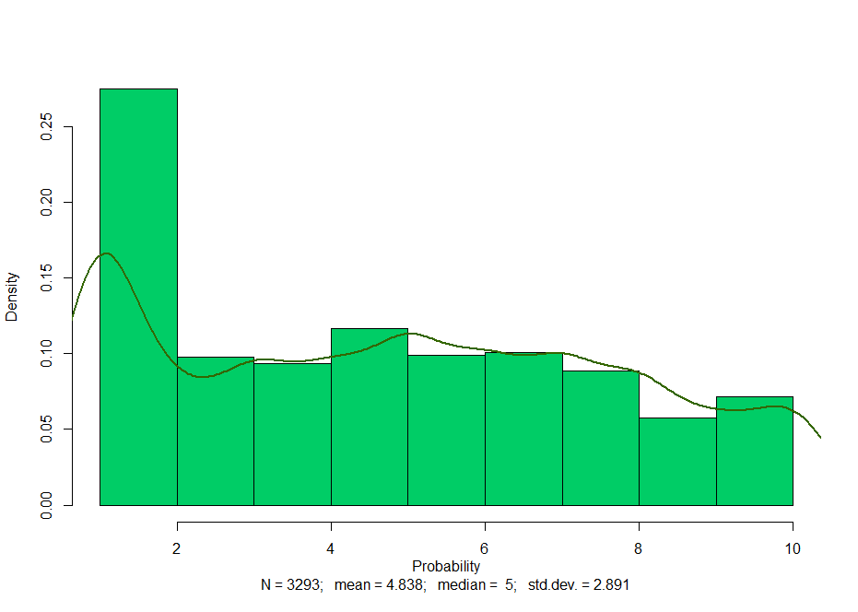

Note: Hereinafter bold green curve is a distribution trend line.

Source: Author from ALLBUS 2018 (Baumann, Schulz, and Thiesen 2019).

**Figure 3.2. Distribution of the dependent variable (probability of voting for the Greens): East Germany**

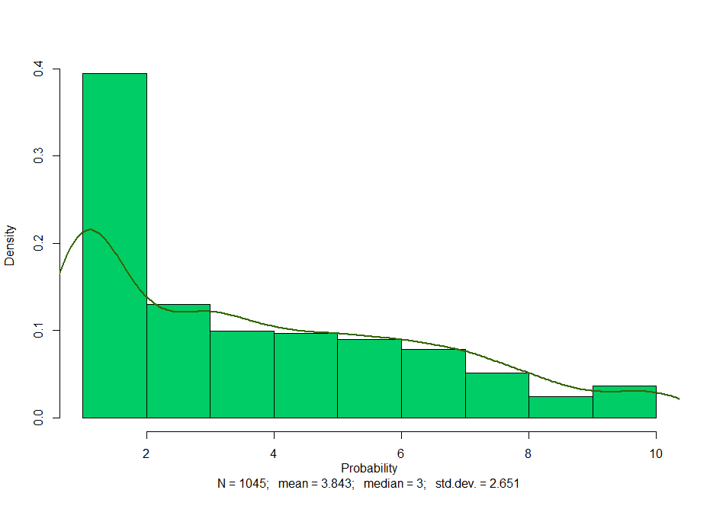

Source: Author from ALLBUS 2018 (Baumann, Schulz, and Thiesen 2019).

**Figure 3.3. Distribution of the dependent variable (probability of voting for the Greens): West Germany**

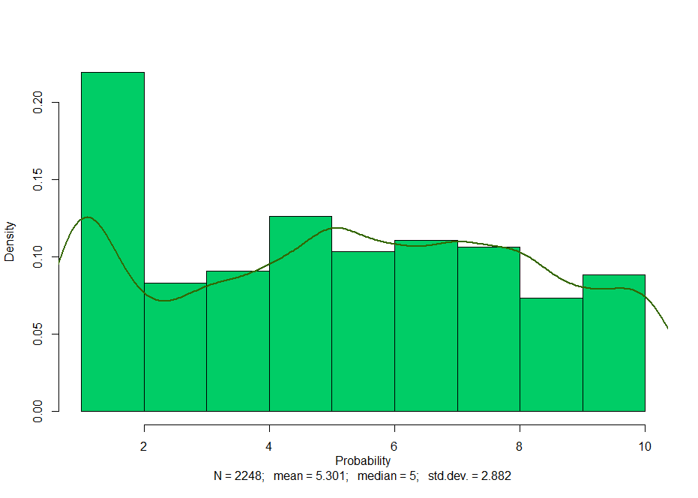

Source: Author from ALLBUS 2018 (Baumann, Schulz, and Thiesen 2019).

**Table 3.1. Descriptive statistics of independent categorical variables: East Germany**

|  |  |  |
| --- | --- | --- |
| *Variable* | *Quantity* | *Share of the whole (%)* |
| Female | 540 | 49.5 |
| Age - Upper-middle (45-60) | 315 | 28.9 |
| Age - Young (18-29) | 101 | 9.2 |
| Occupation - Professional | 138 | 12.7 |
| Occupation - White-collars | 76 | 7 |
| Occupation - Students | 45 | 4.1 |
| Occupation - Grey collars | 215 | 19.7 |
| Occupation - Self-employed | 31 | 3.1 |
| Higher education | 458 | 42 |
| Union membership | 115 | 11 |

Source: Author from ALLBUS 2018 (Baumann, Schulz, and Thiesen 2019).

**Table 3.2. Descriptive statistics of independent interval variables: East Germany**

|  |  |  |  |  |  |
| --- | --- | --- | --- | --- | --- |
| *Variable* | *Mean* | *Median* | *Min.* | *Max.* | *Std. deviation* |
| Ideological self-placement (0 - far left, 10 - far right) | 4.79 | 5 | 1 | 10 | 1.74 |
| Post-material values absorbance | 2.43 | 3 | 1 | 4 | 0.94 |
| Optimism towards immigrants' influx | 9.09 | 9 | 4 | 19 | 3.26 |
| Euro-optimism | 6.66 | 6 | 2 | 14 | 2.78 |
| Trust to federal governemnt | 3.79 | 4 | 1 | 7 | 1.48 |
| Current economic situation. FRG | 2.25 | 2 | 1 | 5 | 0.8 |
| Social protection - primary state aim | 1.65 | 1 | 1 | 5 | 0.88 |

Source: Author from ALLBUS 2018 (Baumann, Schulz, and Thiesen 2019).

**Table 3.3. Descriptive statistics of independent categorical variables: West Germany**

|  |  |  |
| --- | --- | --- |
| *Variable* | *Quantity* | *Share of the whole (%)* |
| Female | 1164 | 48.7 |
| Age - NSM gen. (60-74) | 533 | 22.3 |
| Age - Upper-middle (45-60) | 701 | 29.4 |
| Age - Young (18-29) | 374 | 15.7 |
| Occupation - Professional | 359 | 15 |
| Occupation - White-collars | 204 | 8.5 |
| Occupation - Grey collars | 460 | 19.3 |
| Occupation - Self-employed | 114 | 4.8 |
| Occupation - Students | 125 | 5.2 |
| Higher education | 926 | 38.8 |
| Union membership | 282 | 11.8 |

Source: Author from ALLBUS 2018 (Baumann, Schulz, and Thiesen 2019).

**Table 3.4. Descriptive statistics of independent interval variables: West Germany**

|  |  |  |  |  |  |
| --- | --- | --- | --- | --- | --- |
| *Variable* | *Mean* | *Median* | *Min.* | *Max.* | *Std. deviation* |
| Political ideology | 4.99 | 5 | 1 | 10 | 1.66 |
| Post-material values absorbance | 2.27 | 2 | 1 | 4 | 0.93 |
| Optimism towards immigrants' influx | 10.01 | 10 | 4 | 20 | 3.22 |
| Euro-optimism | 7.38 | 8 | 2 | 14 | 2.75 |
| Trust to federal governemnt | 4.07 | 4 | 1 | 7 | 1.45 |
| Current economic situation. FRG | 2.15 | 2 | 1 | 5 | 0.78 |
| Social protection - primary state aim | 1.9 | 2 | 1 | 5 | 0.95 |

Source: Author from ALLBUS 2018 (Baumann, Schulz, and Thiesen 2019).

***4. Regression output of the models with interaction effects***

**Table 4.1. OLS regression output on respondent’s propensity to vote for the Greens (interaction effects of regions are included)**











Note: *p<0.1; **p<0.05; ***p<0.01. Cells entries are unstandardized regression coefficients and standard errors (in parentheses).

Source: Author from ALLBUS 2018 (Baumann, Schulz, and Thiesen 2019).

***5****.* ***Post-materialism level measurement***

**Table 5.1. Level of post-materialism with respect to Eastern and Western residence**

|  |  |  |  |  |  |  |
| --- | --- | --- | --- | --- | --- | --- |
| *Region* | *Materialist* | *Mixed- materialist* | *Mixed- post-materialist* | *Post-Materialist* | *Non available* | *Total* |
| East Germany | 124 (11.3%) | 431 (39.5%) | 314 (28.8%) | 212 (19.4%) | 9 (0.008%) | 1090 |
|
| West Germany | 186 (7.7%) | 877 (36.7%) | 681 (28.5%) | 607 (25.4%) | 36 (0.15%) | 2387 |
|

Source: Author from ALLBUS 2018 (Baumann, Schulz, and Thiesen 2019).

***6. Additional regression models: individual’s ideological positioning and Green voting***

**Figure 6.1. Plot of the relationship between respondent’s ideological self-placement and his or her propensity to vote for the Greens for both regional samples**

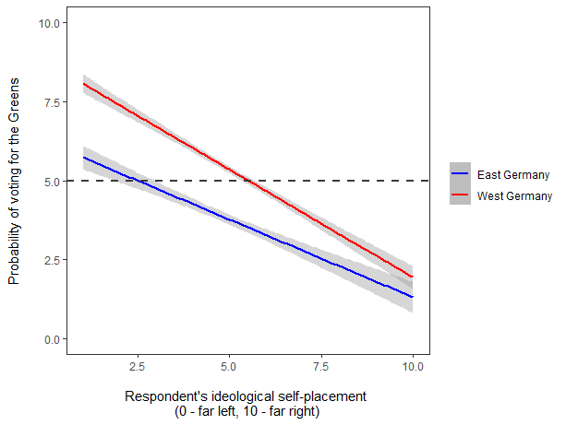

Note: The dashed black line marks the value of Green voting probability equal to five. Grey areas contain 95% confidence intervals.

Source: Author from ALLBUS 2018 (Baumann, Schulz, and Thiesen 2019).

1. Due to the historical specifics of the city of Berlin and absence of information about Eastern or Western Berlin residence of respondents in the ALLBUS 2018 data, results of the Green Party there (19.1 and 27.8 percent in 2014 and 2019 respectively) are not included in neither of the tables.
2. *Age* - “NSM” generation is specified for Western sample solely, *White collars* - managerial or administrative staff; *Grey collars* - employees of service sector, *Higher education* - educational categories presented in accordance with 2011 International Standard Classification of Education (ISCED).
3. Higher education is identified with short cycle tertiary and higher degree. Reference category – all other educational levels and people without any education.
4. Reference category – all other age categories.
5. Reference category – all other occupational groups and retired people.
6. Party identification could be assessed only for 45% of interviewees, whereas 1566 people do not incline towards any political party in Germany (for East and West Germany it is 53.7% and 41% respectively).
7. Reference category – people of other party identification and those without any party ID. Question asked: “Many people in the Federal Republic tend towards a certain political party for a long time, although they do occasionally to choose another party. How is it with you: Generally speaking, do you lean towards a particular party? Please tell me which party it is?”